Fashion MNIST dataset – Mutli-Class Classification

Fashion-MNIST is a dataset of Zalando's article images—consisting of a training set of 60,000 examples and a test set of 10,000 examples. Each example is a 28x28 grayscale image, associated with a label from 10 classes. shares the same image size and structure of training and testing splits.
Here's an example of how the data looks (each class takes three-rows):
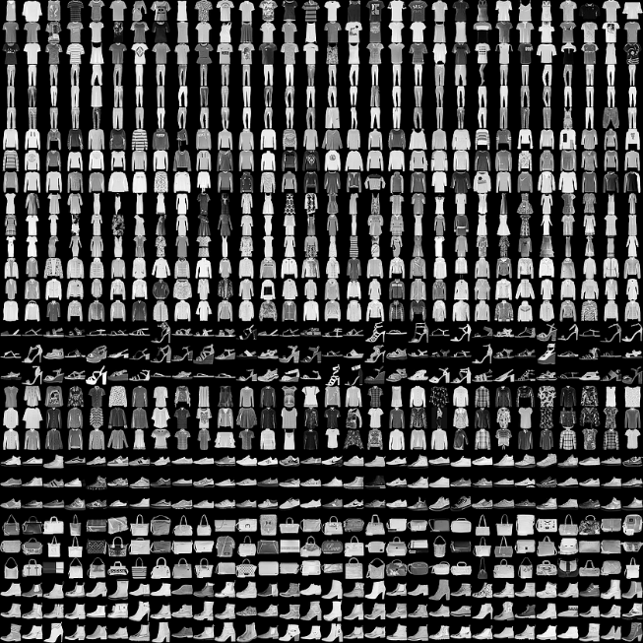

Target Variable Handling in Multi-Class Classification
Approach Used:
In multi-class classification, the target variable is transformed into a binary matrix (one-hot encoding), where each class is represented as a vector with a 1 for the correct class and 0 for all others.
The categorical_crossentropy loss function is then used, which calculates the difference between the predicted probability distribution and the one-hot encoded true labels. This approach is suitable for models with a SoftMax output layer that predicts probabilities for each class.
Answer the following questions:
- Plot the training and validation error and accuracy metrics.
- What hyperparameters did you use to tune your model and why? For
example, the number of hidden layers, number of neurons, activation function, input features, etc.

